1) Install Terraform on your PC

What is Terraform?
Terraform Official Website
Terraform is an Infrastructure as Code (IaC) tool by HashiCorp used to create and manage cloud resources automatically.
Examples:
- AWS EC2 instances
- Azure VMs
- GCP resources
- Kubernetes clusters
- Networking infrastructure

STEP 1 — Download Terraform
Open the official Terraform downloads page:
Terraform Downloads Page
Now:
- Select your OS:
  - Windows
  - Linux
  - macOS
- Click:
  - Windows AMD64 (for most PCs)
A ZIP file will download.
Example:
terraform_1.x.x_windows_amd64.zip
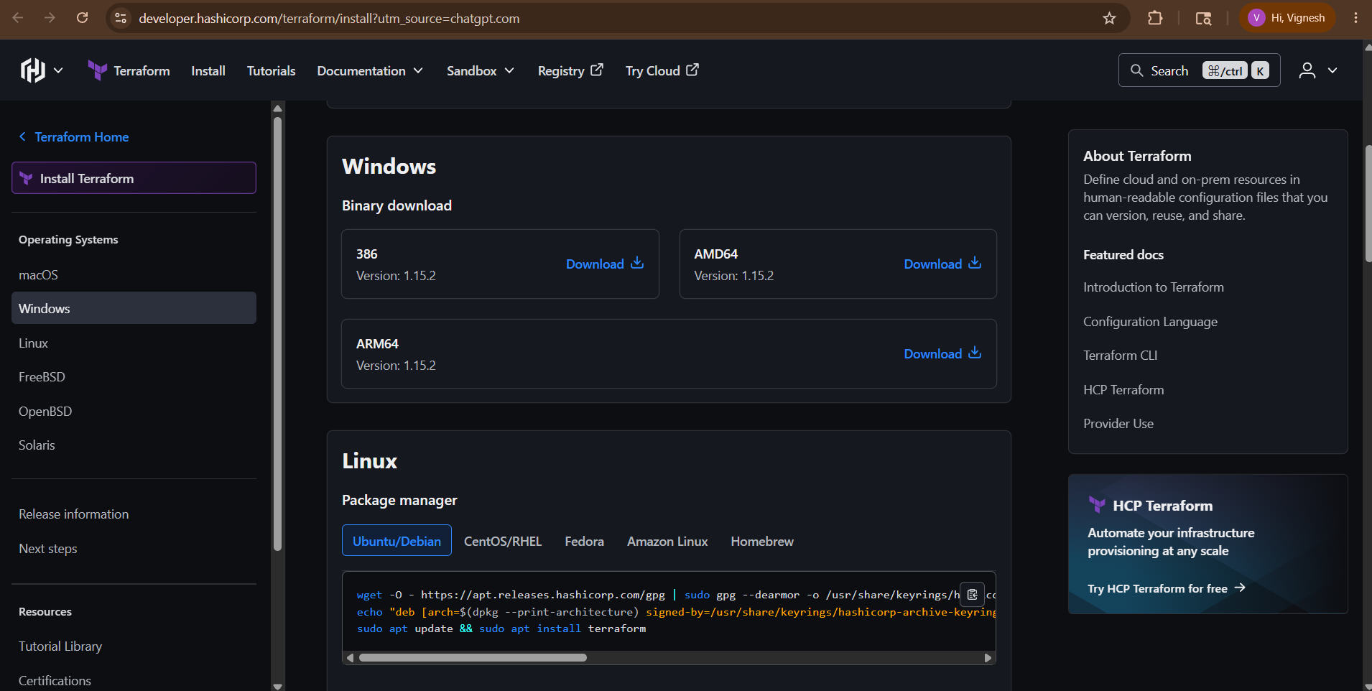

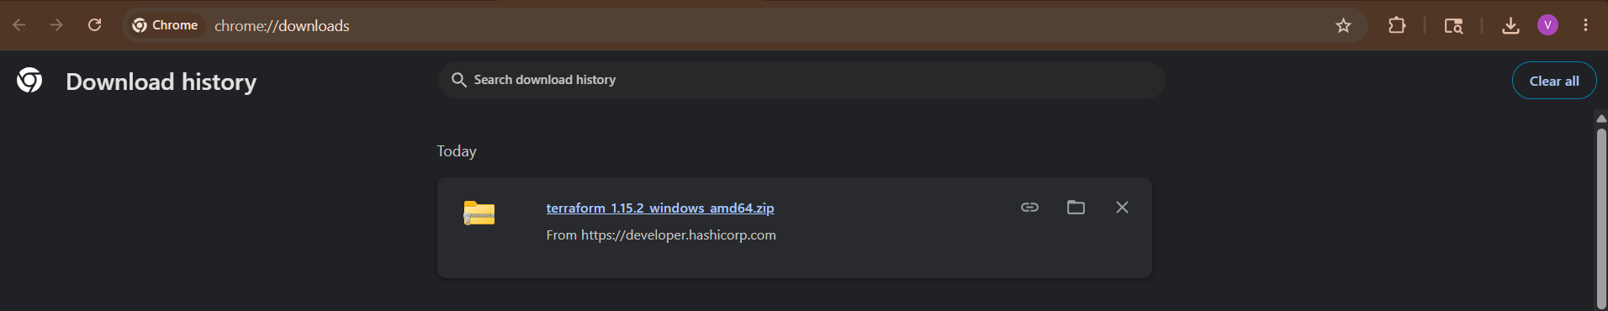

STEP 2 — Extract the ZIP File
- Go to Downloads folder
- Right-click ZIP
- Click:
Extract All
You will get:
terraform.exe
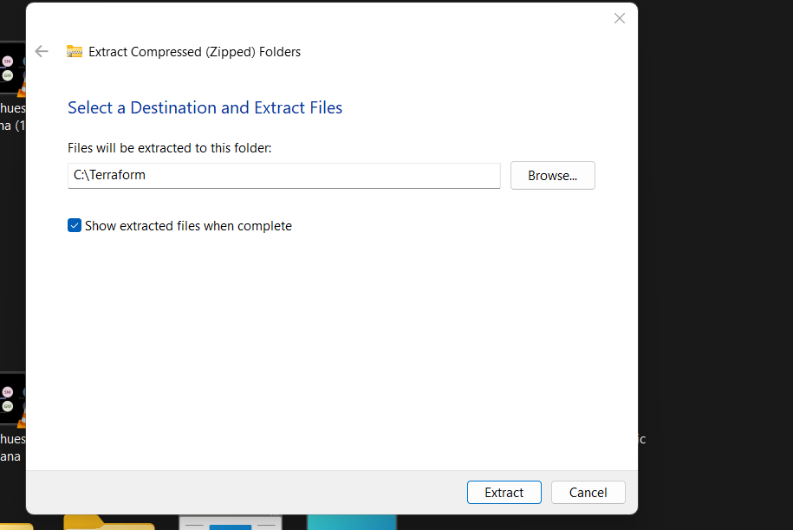

STEP 3 — Create Terraform Folder
Create a permanent folder:
C:\Terraform
Now copy:
terraform.exe
into:
C:\Terraform
Final path:
C:\Terraform\terraform.exe
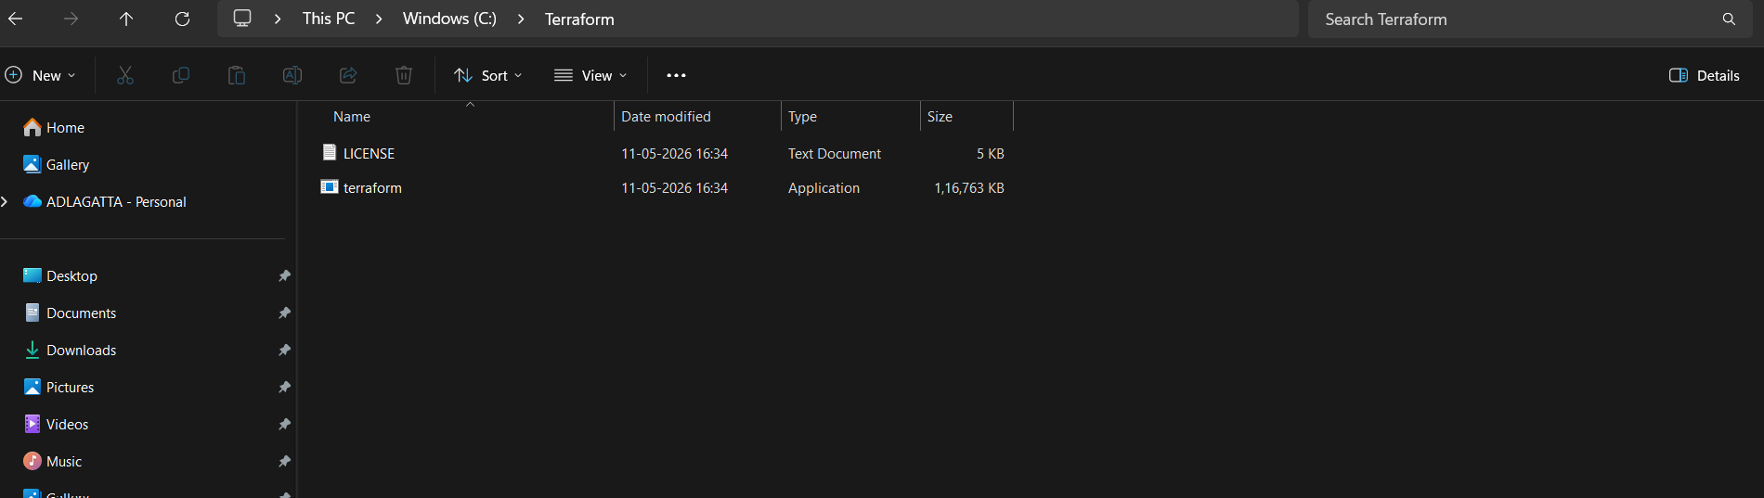

STEP 4 — Add Terraform to Environment Variables
This is VERY important.
Open Environment Variables
Press:
Windows + S
Search:
Environment Variables
Open:
Edit the system environment variables
Then:
Click
Environment Variables

STEP 5 — Edit PATH Variable
Under:
System Variables
Find: Path
Click: Edit
Then: New
Add: C:\Terraform
Click: OK
Close all windows with OK.
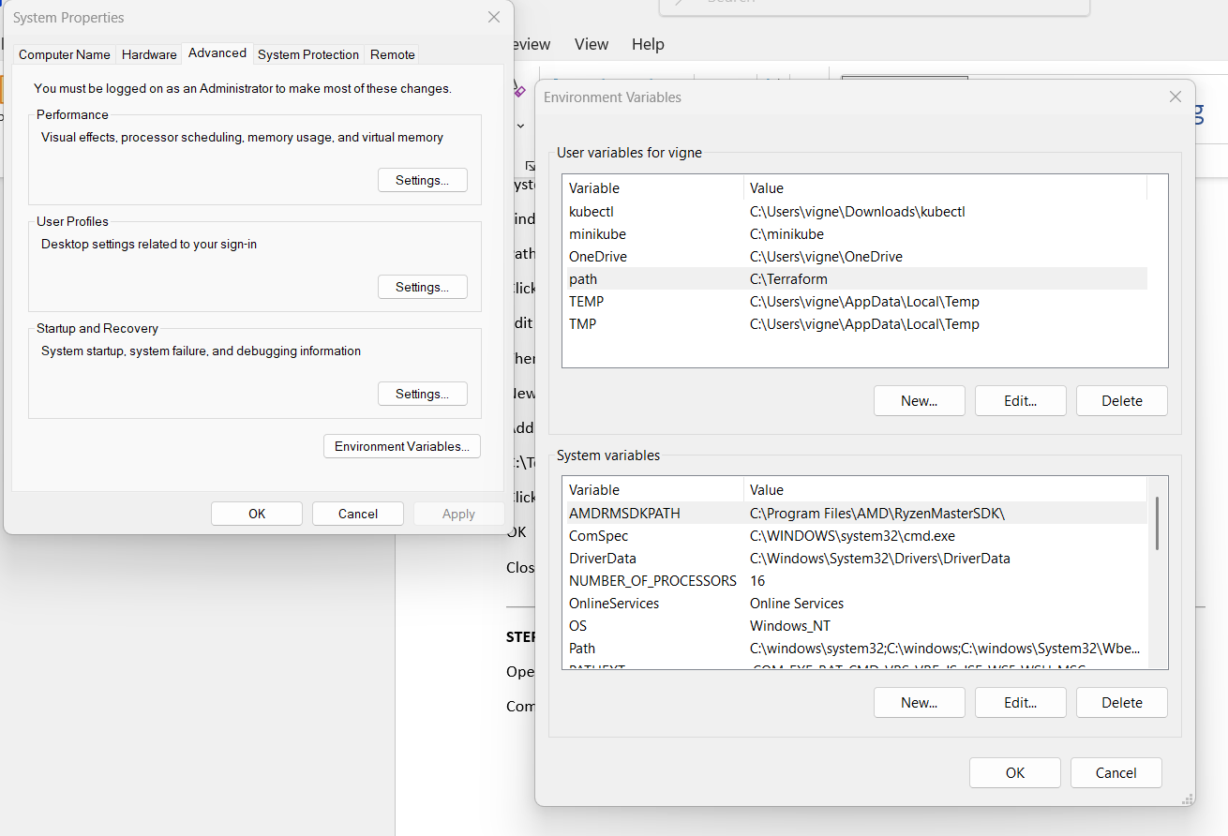

STEP 6 — Verify Installation
Open:
Command Prompt
Run:
terraform -version
If successful:
Terraform v1.x.x
Example:
Terraform v1.8.5
Terraform is installed successfully.
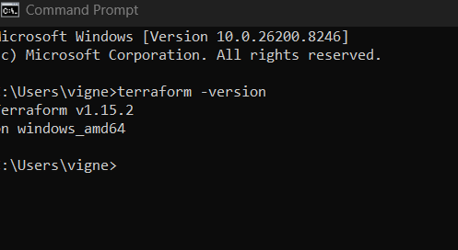

STEP 7 — Test Terraform
Create a folder:
terraform-demo
Inside create file:
main.tf
Add:
terraform {
required_version = ">= 1.0"
}
Save it.
Open CMD inside folder:
terraform init
If successful:
Terraform has been successfully initialized!
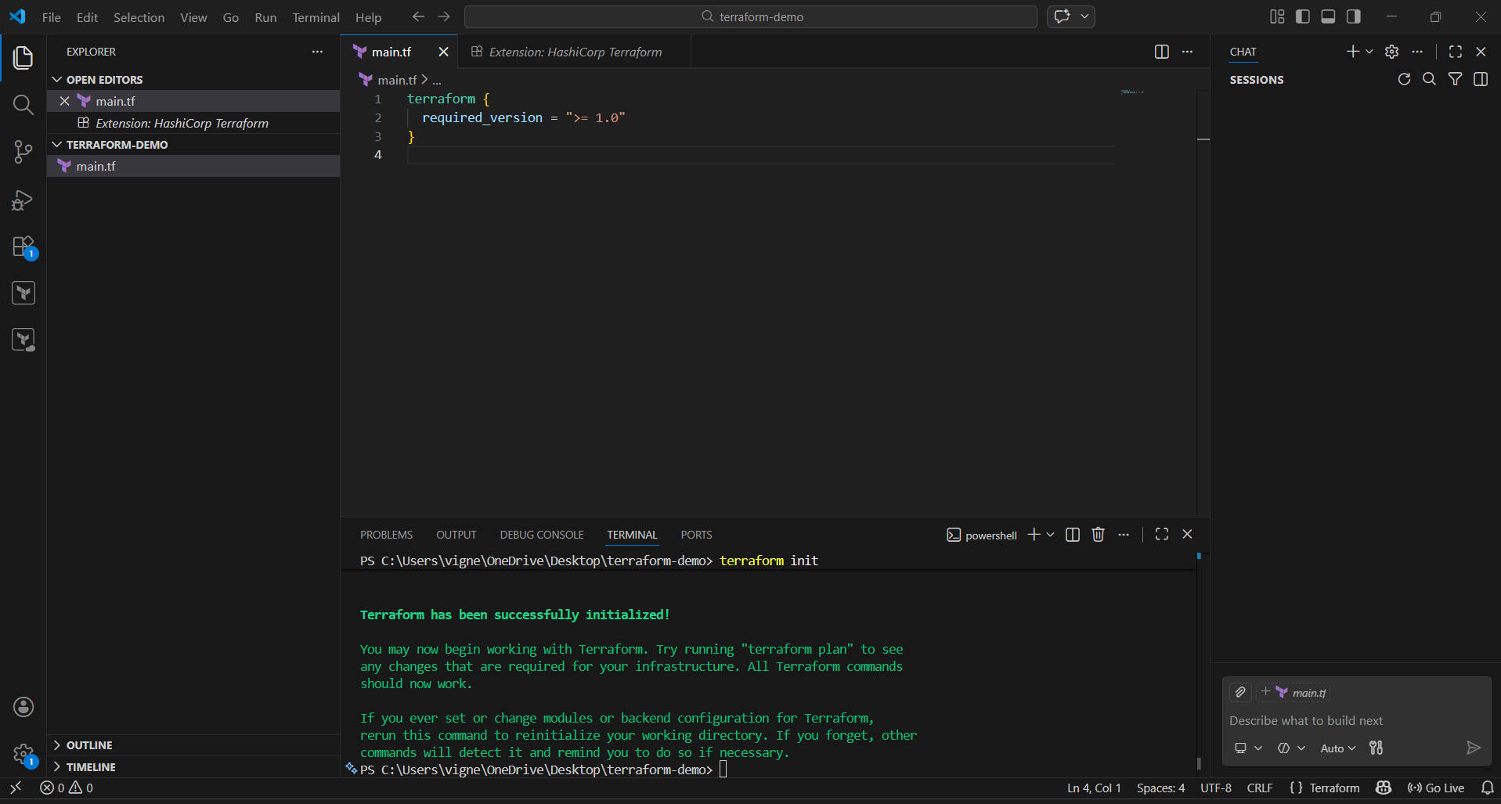

Common Errors & Fixes
Error:
terraform is not recognized
Fix:
PATH variable not added correctly.
Restart:
- CMD
- VS Code
- Or restart PC

Recommended Tools
Install VS Code
Visual Studio Code
Install Terraform Extension
Open VS Code → Extensions → Search:
Terraform
Install extension by HashiCorp.

First Useful Commands
terraform init
terraform plan
terraform apply
terraform destroy

Example Workflow
terraform init
terraform plan
terraform apply

2) Execute all the templates shown in video.

STEP 1 — Create Project Folder
Create a folder:
terraform-demo
Open this folder in:
Visual Studio Code

STEP 2 — Create Terraform File
Create file:
main.tf
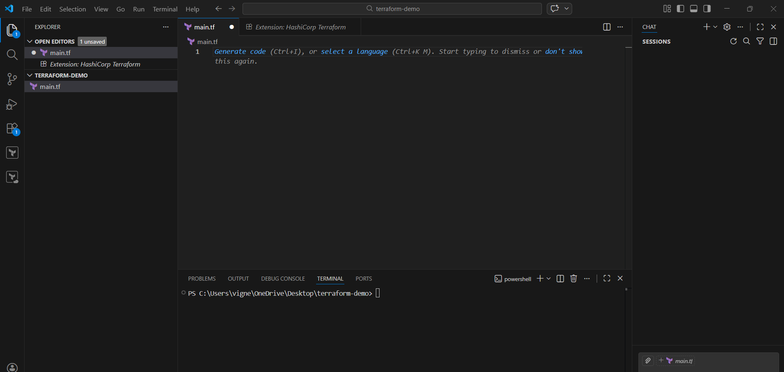

STEP 3 — Add Correct Terraform Code
Template 1 — Create Local File
Paste this:
resource "local_file" "pet" {
filename = "pets.txt"
content = "we love pets!"
}
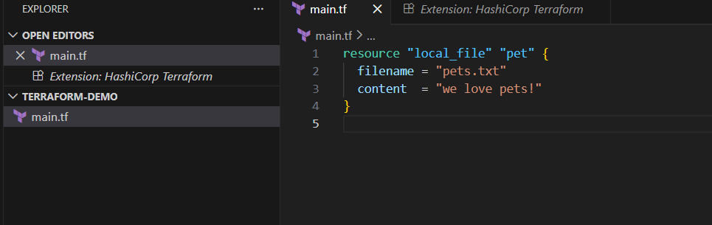

What This Does
Terraform will create:
pets.txt
inside your project folder with content:
we love pets!

STEP 4 — Initialize Terraform
Open terminal in VS Code.
Run:
terraform init
You will see something like:
Initializing provider plugins...
- Finding latest version of hashicorp/local...
- Installing hashicorp/local...
Terraform has been successfully initialized!
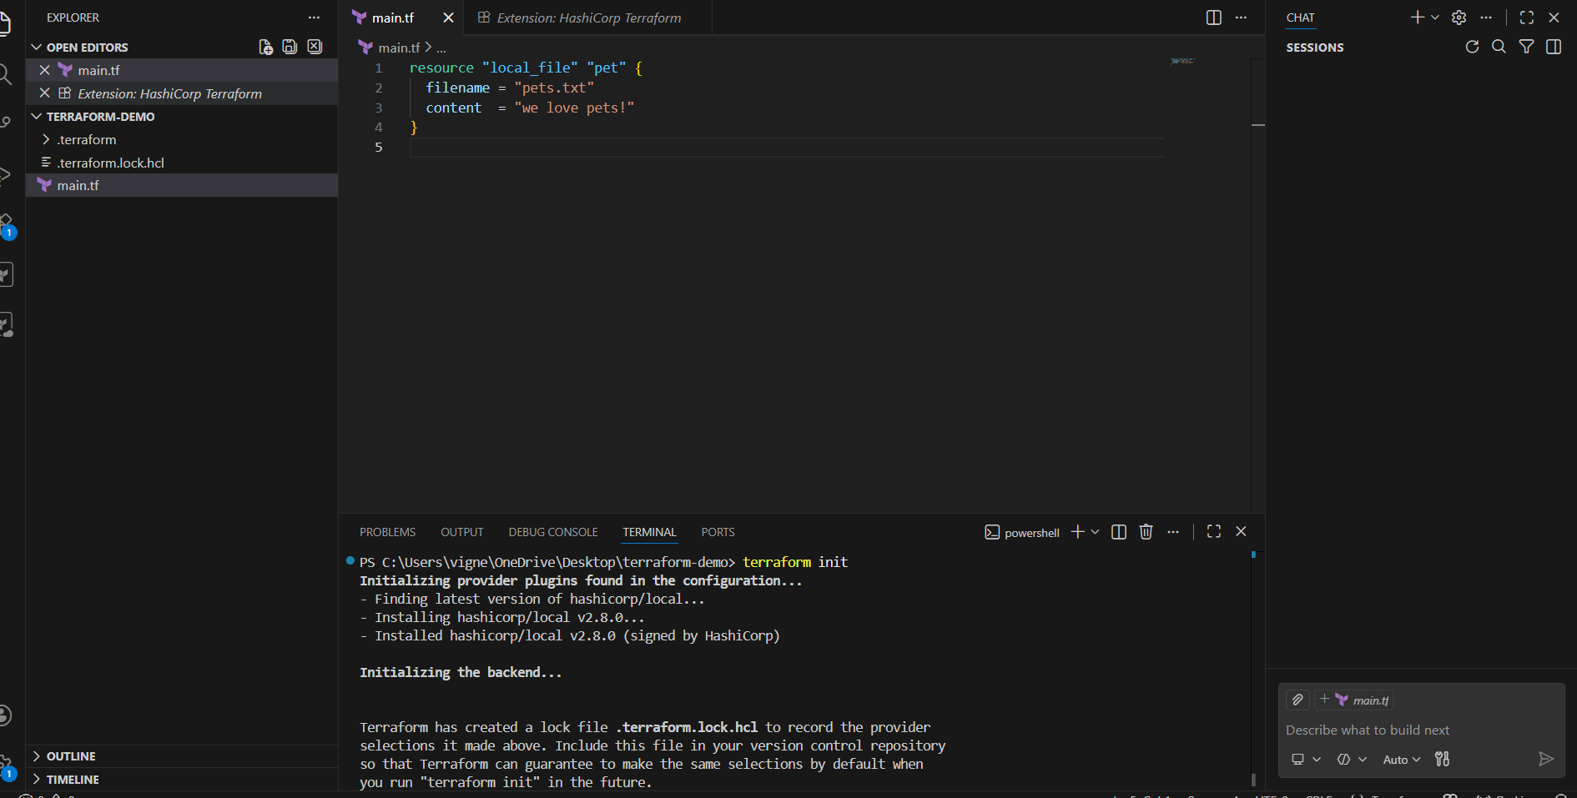
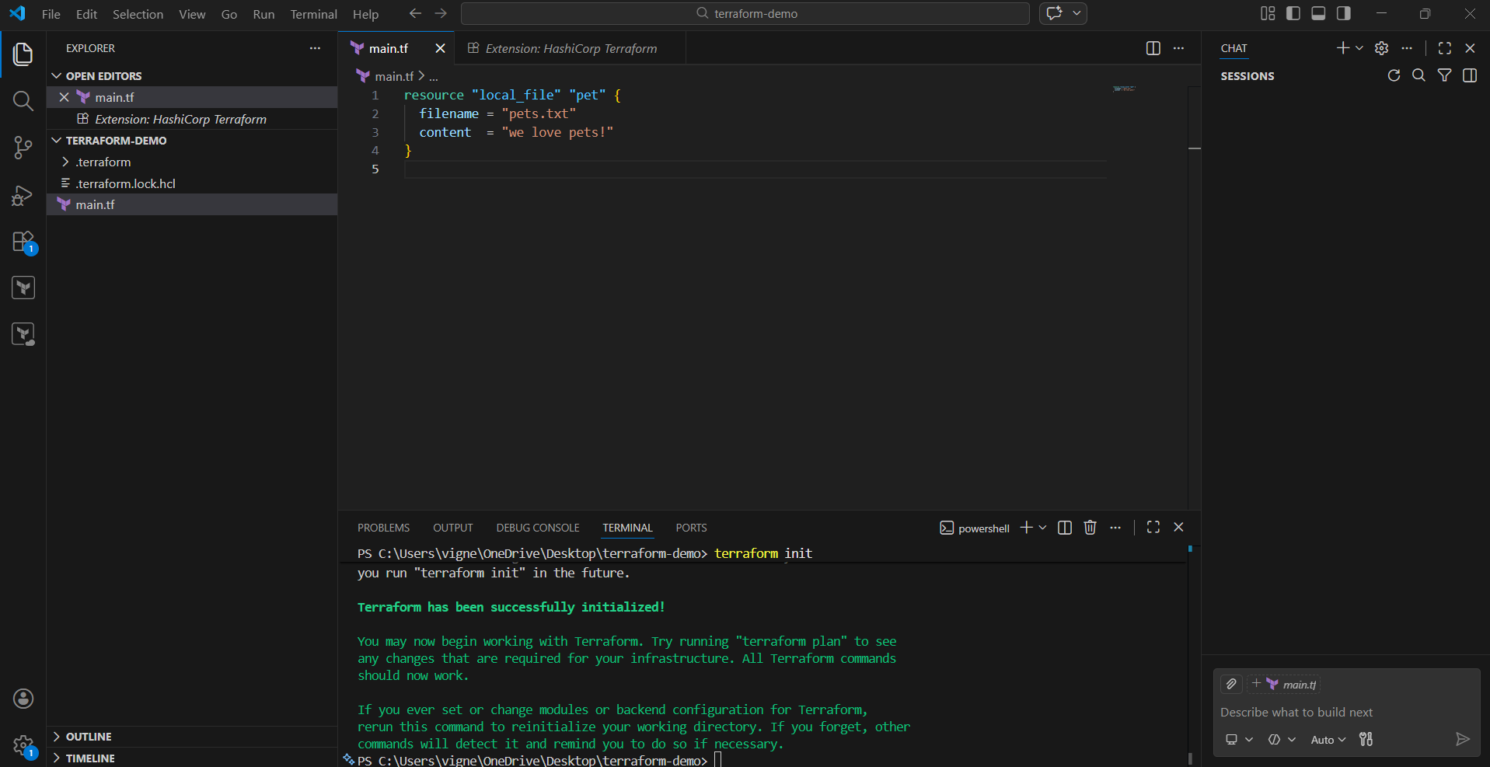

STEP 5 — See Execution Plan
Run:
terraform plan
Terraform shows what it will create.
Example:
+ create local_file.pet
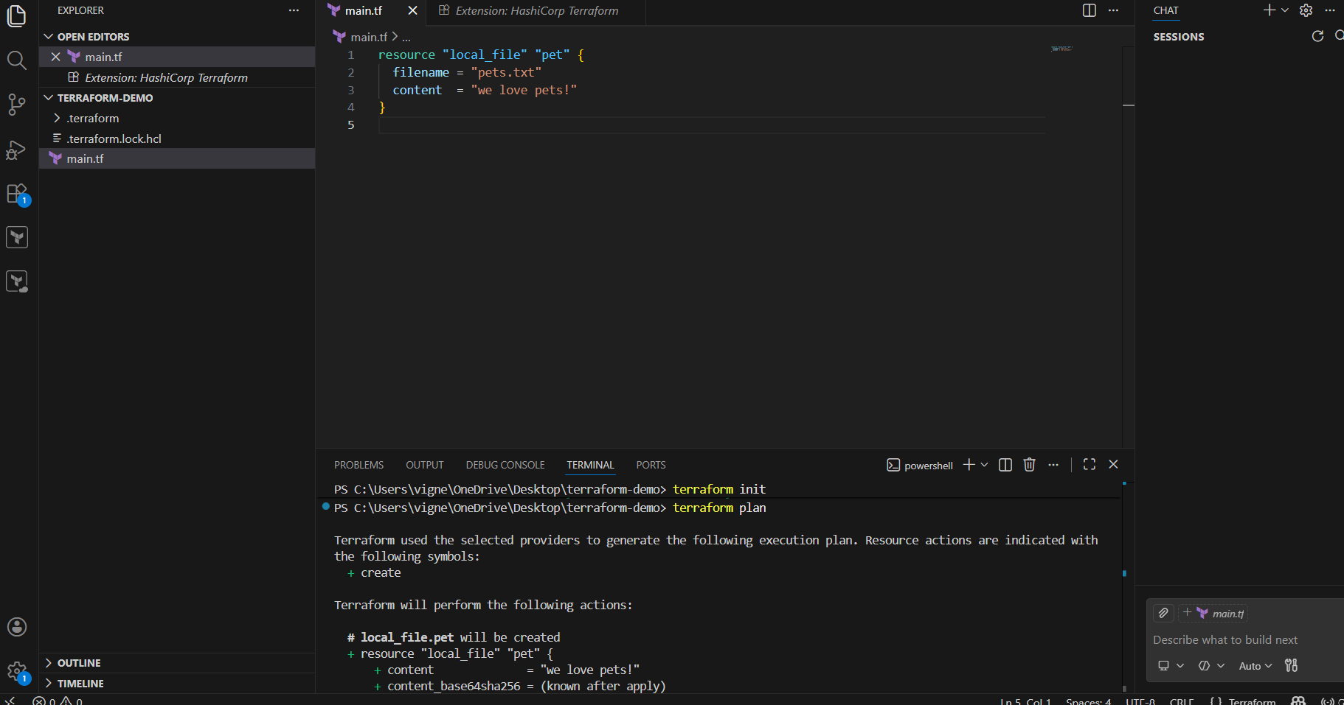
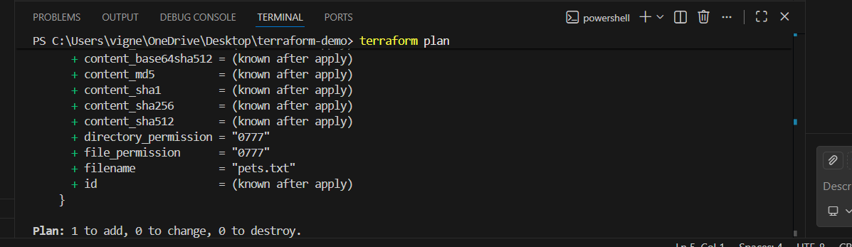

STEP 6 — Apply Changes
Run:
terraform apply
It will ask:
Do you want to perform these actions?
Type:
yes
Press Enter.
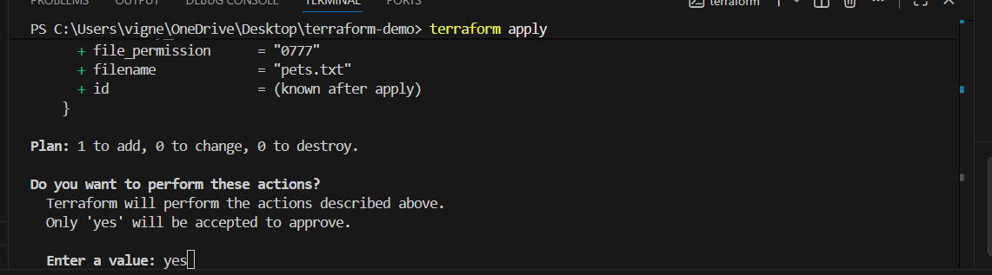
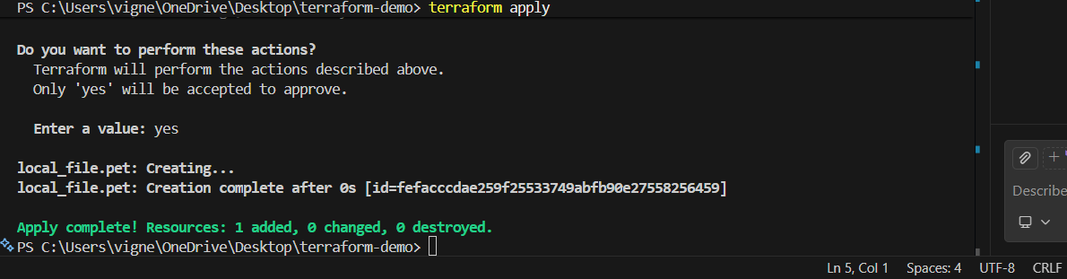

STEP 7 — Verify Output
Inside your folder you will see:
pets.txt
terraform.tfstate
Open:
pets.txt
You’ll see:
we love pets!
First Terraform resource executed successfully.
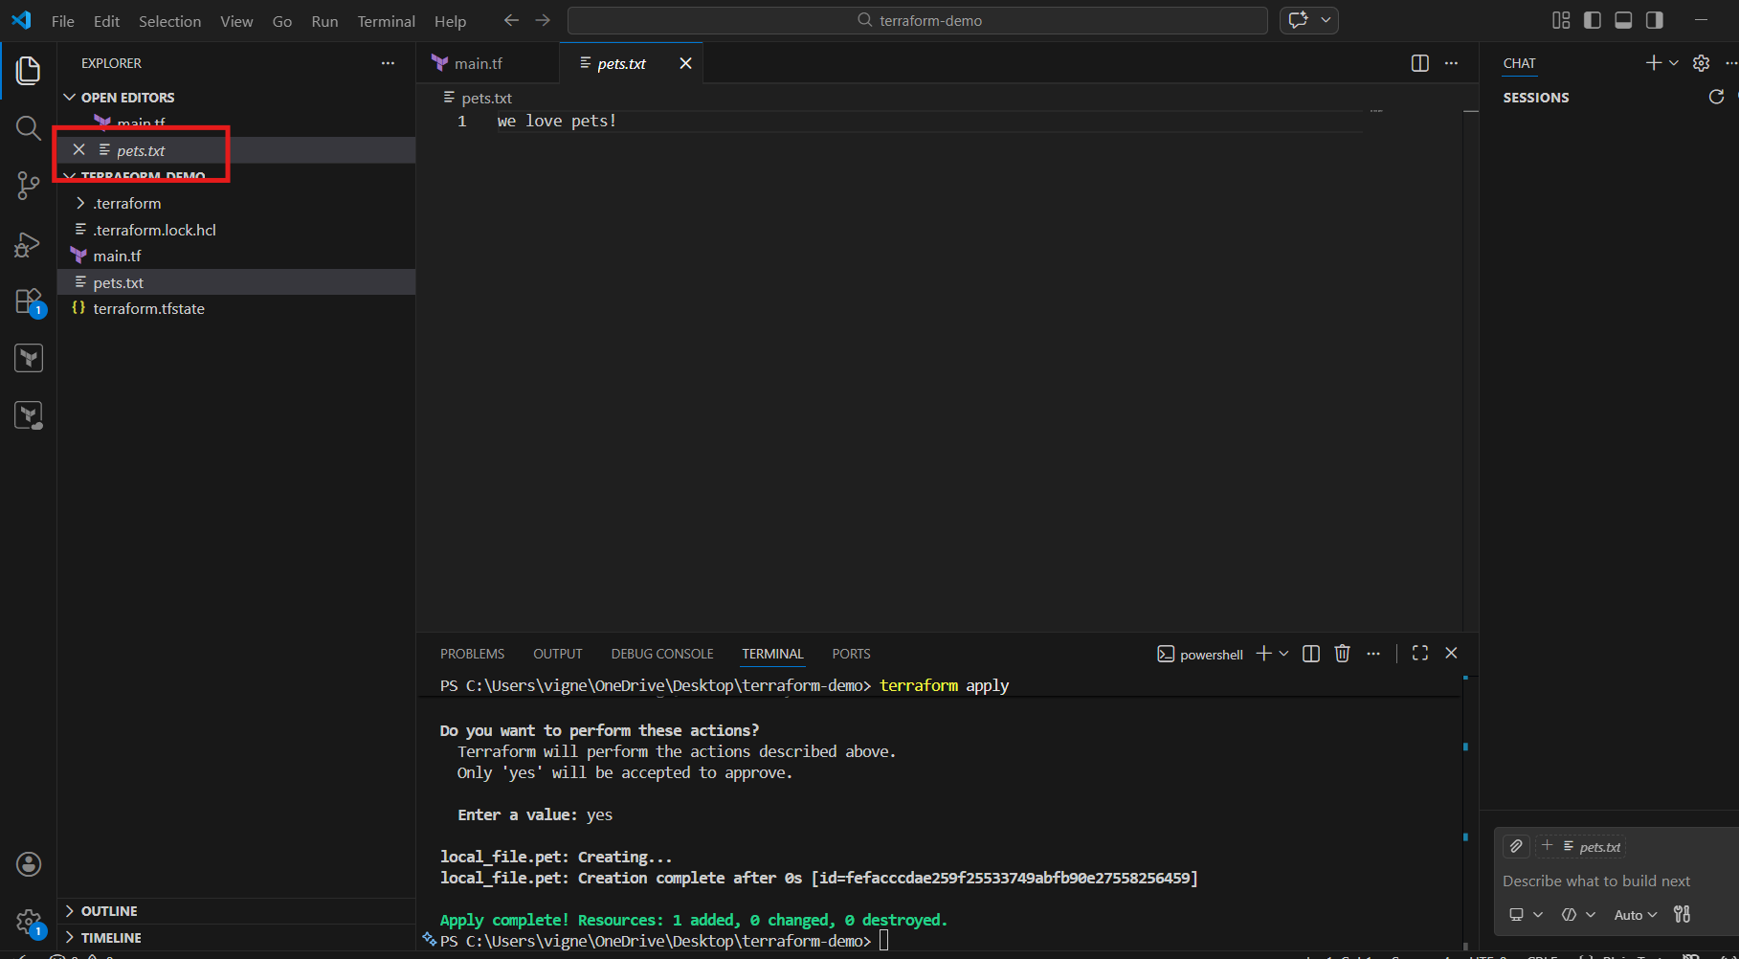

STEP 8 — Add Random Pet Resource
Now replace your code with this FULL correct version:
resource "local_file" "pet" {
filename = "pets.txt"
content = "we love pets!"
}
resource "random_pet" "mypet" {
prefix = "MR"
separator = "."
length = 1
}
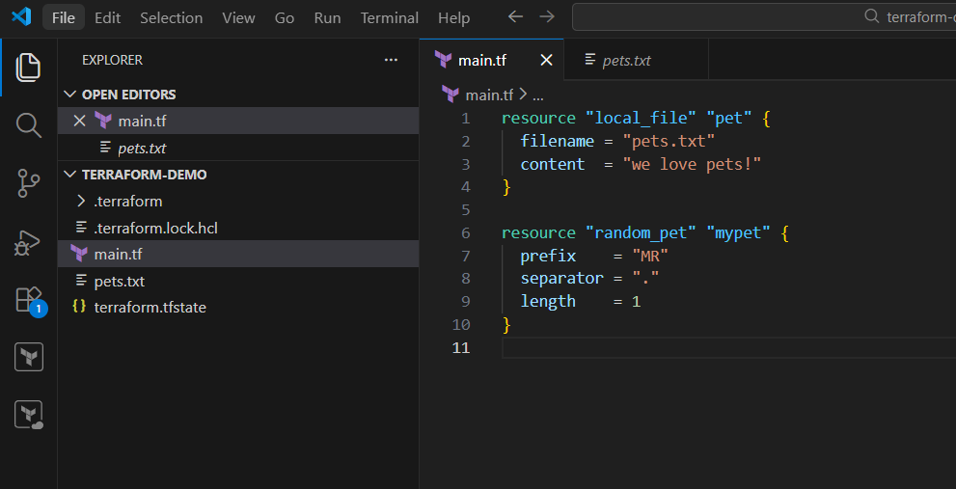

Important Fixes
You wrote:
length = "1"
Correct:
length = 1
Because length must be a NUMBER, not string.

STEP 9 — Reinitialize Providers
Since you added a new provider (random), run again:
terraform init
Terraform downloads:
- local provider
- random provider
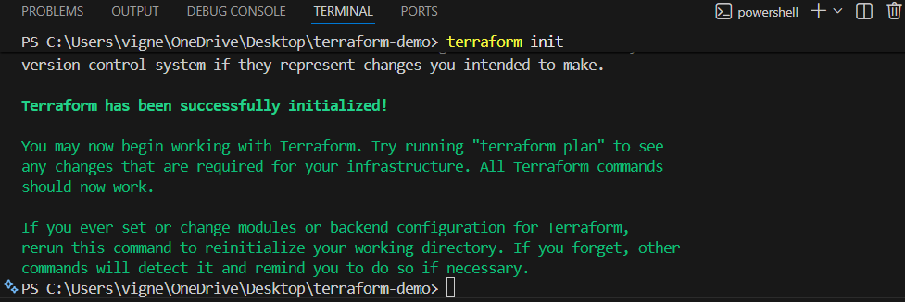

STEP 10 — Run Plan Again
terraform plan
You’ll see:
+ random_pet.mypet
Example generated name:
MR.rabbit
or
MR.cat
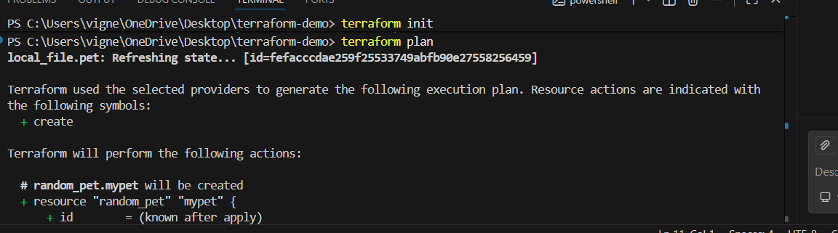
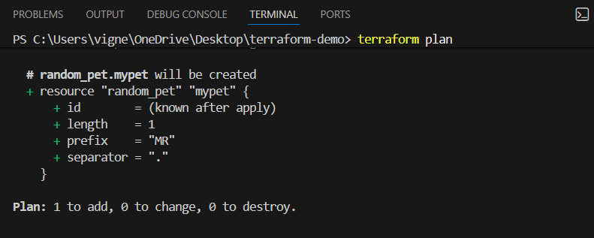

STEP 11 — Apply Again
terraform apply
Type:
Yes
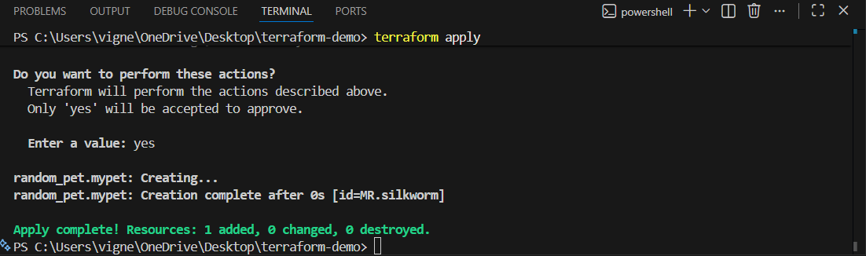

STEP 12 — See Terraform State
Run:
terraform state list
Output:
local_file.pet
random_pet.mypet
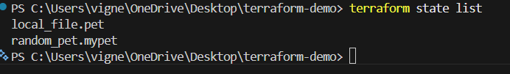

STEP 13 — Show Random Pet Output
Add this below resources:
output "pet-name" {
value = random_pet.mypet.id
}

Full code:
resource "local_file" "pet" {
filename = "pets.txt"
content = "we love pets!"
}
resource "random_pet" "mypet" {
prefix = "MR"
separator = "."
length = 1
}
output "pet-name" {
value = random_pet.mypet.id
}
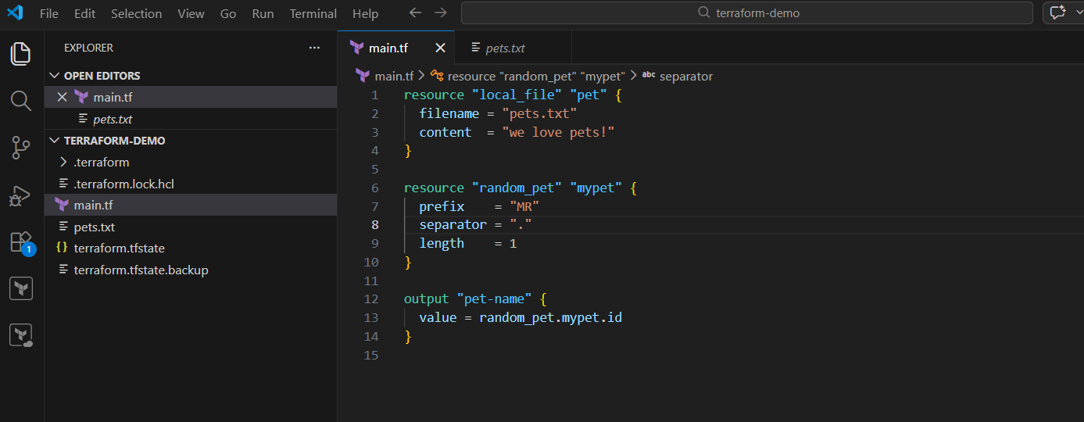

STEP 14 — Apply Again
Run:
terraform apply
Output:
pet-name = "MR.rabbit"
Now Terraform generated dynamic values.
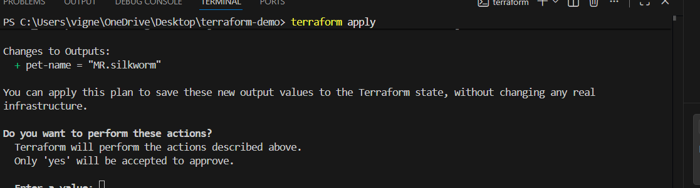
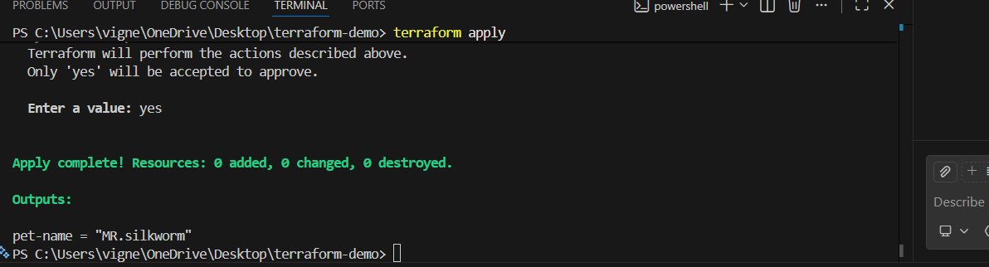

STEP 15 — Destroy Resources
To remove everything:
terraform destroy
Type:
yes
Terraform removes:
- local file
- random resource
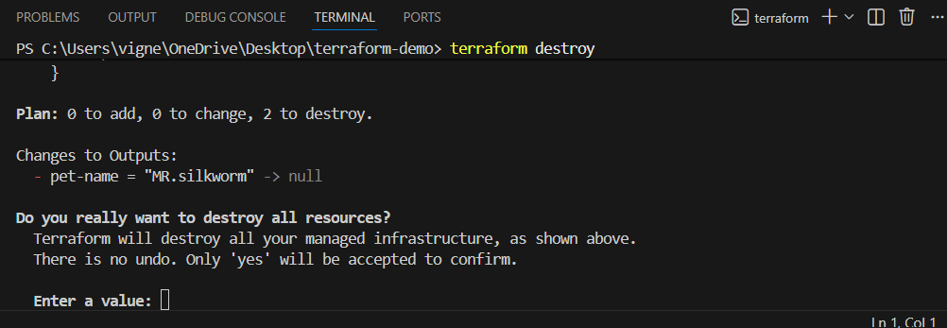
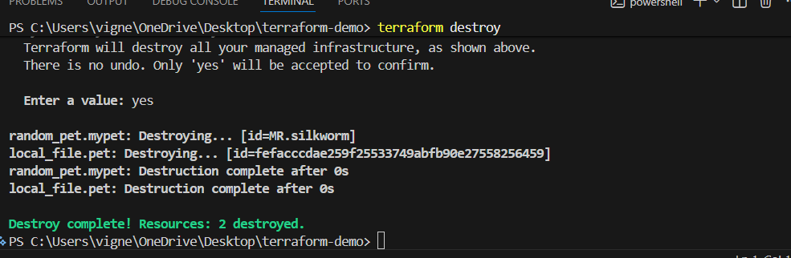

Understanding the Syntax
Resource Block
resource "TYPE" "NAME"
Example:
resource "local_file" "pet"
- TYPE → provider resource type
- NAME → local reference name

Accessing Resource Values
random_pet.mypet.id
Means:
RESOURCE_TYPE.RESOURCE_NAME.ATTRIBUTE

Useful Commands
terraform init
terraform validate
terraform fmt
terraform plan
terraform apply
terraform destroy
terraform state list

Folder Structure After Execution
terraform-demo/
│
├── main.tf
├── pets.txt
├── terraform.tfstate
├── terraform.tfstate.backup
└── .terraform/

3) Note down below points, Terraform Init Terraform Plan Terraform Apply Terraform Provider.

Terraform Important Commands
1) Terraform Init
What is Terraform Init?
terraform init is the FIRST command used in every Terraform project.
It initializes the Terraform working directory.

What Happens Internally?
When you run:
terraform init
Terraform:
- Downloads required providers
- Creates .terraform folder
- Initializes backend
- Prepares working directory
- Creates lock file

Example
Create File
main.tf
Add:
resource "local_file" "pet" {
filename = "pets.txt"
content = "we love pets!"
}

Run Command
terraform init

Output Example
Initializing the backend...
Initializing provider plugins...
- Finding latest version of hashicorp/local...
- Installing hashicorp/local...
Terraform has been successfully initialized!

Files Created After Init
.terraform/
terraform.lock.hcl

Important Point
Without terraform init:
❌ Terraform will NOT work.
You must run it:
- First time project setup
- After adding new provider
- After changing backend

2) Terraform Plan
What is Terraform Plan?
terraform plan shows:
✅ What Terraform WILL create/change/delete
before actually doing it.
It is a PREVIEW command.

Command
terraform plan

What Happens Internally?
Terraform:
- Reads .tf files
- Compares current infrastructure
- Compares Terraform state
- Creates execution plan

Example Output
Terraform will perform the following actions:
+ create local_file.pet
Plan: 1 to add, 0 to change, 0 to destroy.

Symbols Meaning
Symbol | Meaning
+ | Create
- | Destroy
~ | Modify
-/+ | Replace

Important Point
terraform plan
❌ does NOT create resources.
It only shows preview.

Why Use Plan?
Benefits:
- Detect mistakes
- Verify changes
- Avoid accidental deletion
- Safer deployments

3) Terraform Apply
What is Terraform Apply?
terraform apply actually CREATES infrastructure/resources.
This is the REAL execution command.

Command
terraform apply

What Happens Internally?
Terraform:
- Reads configuration
- Creates execution plan
- Asks approval
- Creates/updates resources
- Updates state file

Example
Do you want to perform these actions?
Type:
yes
Press Enter.

Example Output
local_file.pet: Creation complete
Apply complete! Resources: 1 added.

Files Created
terraform.tfstate
terraform.tfstate.backup

Important Point
terraform apply
✅ makes REAL changes.
So be careful in cloud environments like:
- AWS
- Azure
- GCP
because it may create billable resources.

Auto Approve Mode
terraform apply -auto-approve
Skips confirmation.
Mostly used in:
- CI/CD pipelines
- Jenkins
- GitHub Actions

4) Terraform Provider
What is a Provider?
Provider = Plugin that allows Terraform to interact with platforms/services.
Examples:
- AWS
- Azure
- GCP
- Kubernetes
- Docker
- Local
- Random

Provider Block Example
terraform {
required_providers {
local = {
source = "hashicorp/local"
version = ">= 2.0"
}
}
}

Example Providers
Provider |  |  | Purpose
local |  |  | Create local files
random |  |  | Generate random values
aws |  |  | Manage AWS resources
azurerm |  |  | Manage Azure
google |  |  | Manage GCP
kubernetes |  |  | Manage Kubernetes

How Providers Work
When you run:
terraform init
Terraform downloads provider plugins automatically.
Stored inside:
.terraform/

Example Resource Using Provider
resource "random_pet" "mypet" {
prefix = "MR"
separator = "."
length = 1
}
This uses:
random provider

Provider Registry
Official provider registry:
Terraform Registry

Full Beginner Workflow
Step 1 — Create File
main.tf

Step 2 — Write Code
resource "local_file" "pet" {
filename = "pets.txt"
content = "we love pets!"
}

Step 3 — Initialize
terraform init

Step 4 — Preview
terraform plan

Step 5 — Execute
terraform apply

Real DevOps Flow
terraform init
terraform validate
terraform fmt
terraform plan
terraform apply

Important Points
Command |  |  | Purpose
terraform init |  |  | Initialize Terraform project
terraform plan |  |  | Preview infrastructure changes
terraform apply |  |  | Create/update infrastructure
provider |  |  | Connect Terraform to services

Most Important Files
File |  |  | Purpose
main.tf |  |  | Terraform configuration
terraform.tfstate |  |  | Infrastructure state
terraform.lock.hcl |  |  | Provider lock versions
.terraform/ |  |  | Downloaded providers

Common Beginner Errors
Error:
terraform not recognized
Fix:
Add Terraform to PATH.

Error:
provider not found

Fix:
Run:
terraform init

Error:
No configuration files
Fix:
Ensure:
main.tf
exists in current folder.

4) Integrate a sample Terraform template in Jenkins

Architecture Flow
Developer → Jenkins → Terraform → Infrastructure

Prerequisites
You need:
Tool |  | Required
Java |  | ✅
Jenkins |  | ✅
Terraform |  | ✅
Git |  | ✅

STEP 1 — Install Java
Check Java:
java -version
If not installed:
Download Java
Oracle Java Downloads
OR
Eclipse Temurin JDK
Install Java 17 or later.

STEP 2 — Install Jenkins
Download Jenkins
Jenkins Official Website
Install:
Windows Installer (.msi)

STEP 3 — Start Jenkins
Open browser:
http://localhost:8080

STEP 4 — Unlock Jenkins
Password location:
C:\Program Files\Jenkins\secrets\initialAdminPassword
Copy password → Paste in browser.

STEP 5 — Install Suggested Plugins
Click:
Install suggested plugins
Wait for installation.

STEP 6 — Create Admin User
Add:
- Username
- Password
- Email
Save.

STEP 7 — Install Terraform on PC
Already covered earlier.
Verify:
terraform -version

STEP 8 — Install Git
Download:
Git Official Website
Verify:
git –version
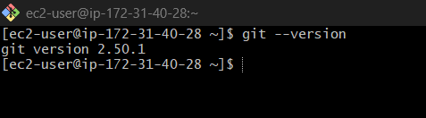

STEP 1 — Enter Jenkins Container
Run on EC2:
docker exec -it jenkins bash
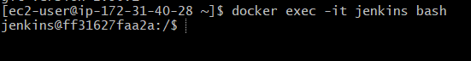

2 — Create Terraform Project Folder
Inside container:
mkdir -p /var/jenkins_home/terraform-demo
cd /var/jenkins_home/terraform-demo
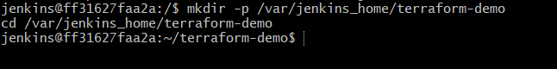

STEP 3 — Create Terraform File
Run:
cat > main.tf
Paste:
resource "local_file" "pet" {
filename = "pets.txt"
content = "Terraform executed from Jenkins!"
}
resource "random_pet" "mypet" {
prefix = "MR"
separator = "."
length = 1
}
output "pet_name" {
value = random_pet.mypet.id
}

Then press:
CTRL + D
to save.
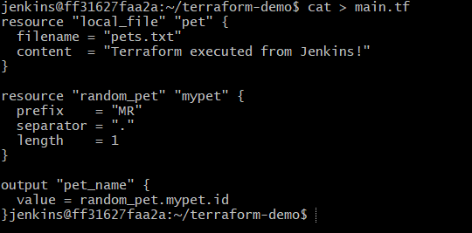

STEP 4 — Verify File
ls
You should see:
main.tf
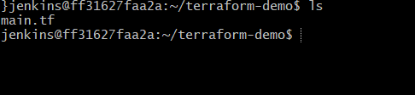

Exit container first:
exit

Now Enter Container as ROOT
Run from EC2 terminal:
docker exec -u 0 -it jenkins bash
Explanation:
- -u 0
→ opens container as root user

STEP 5 — Install Terraform INSIDE Jenkins Container
Still inside container:
apt update
apt install -y wget unzip
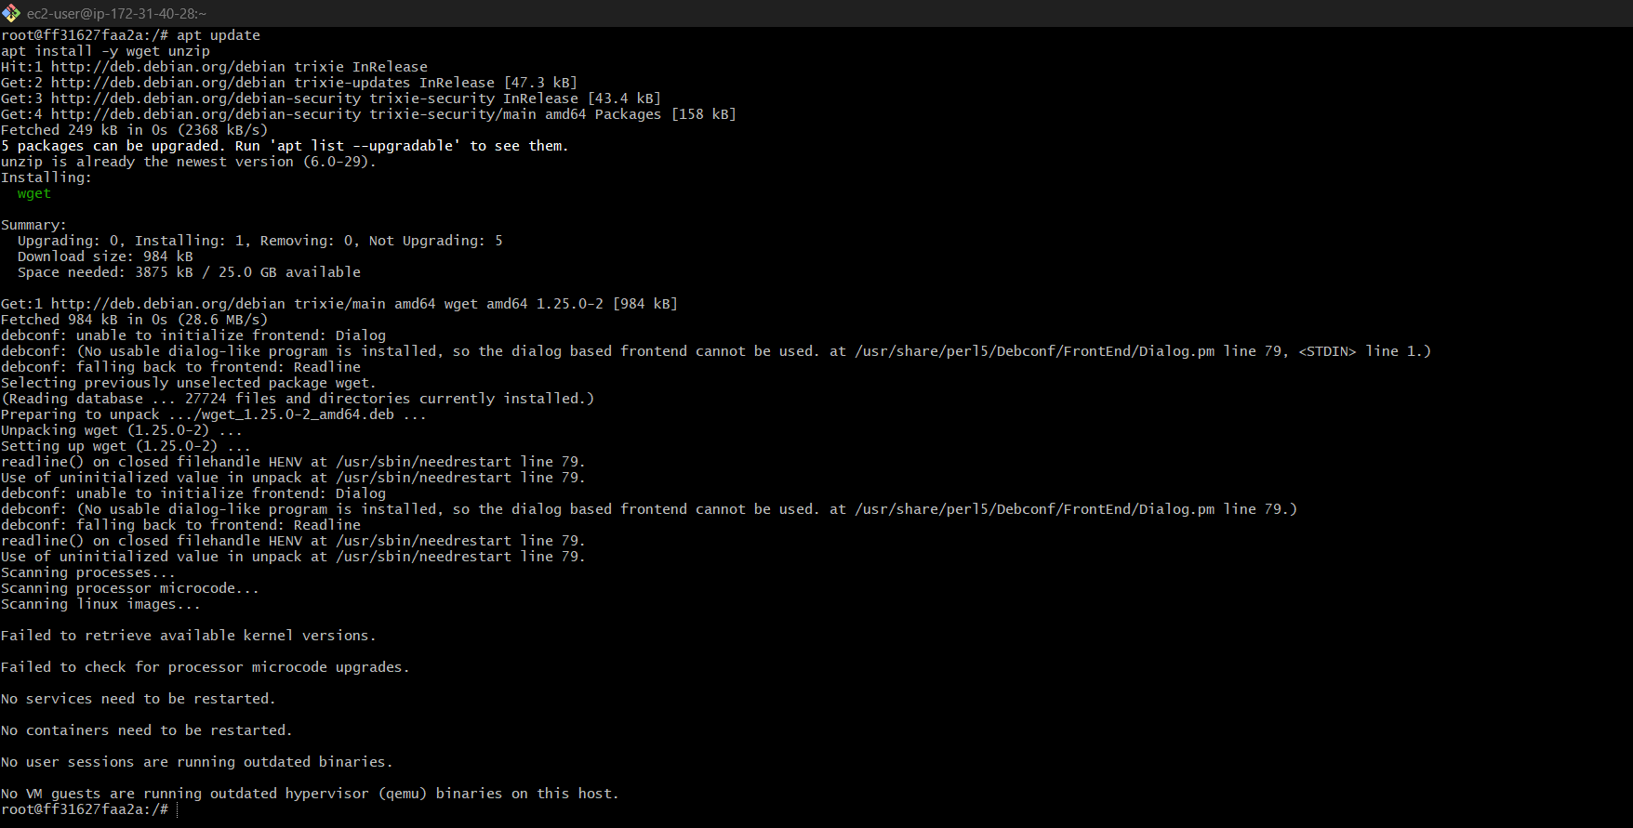

Download Terraform
wget https://releases.hashicorp.com/terraform/1.8.5/terraform_1.8.5_linux_amd64.zip
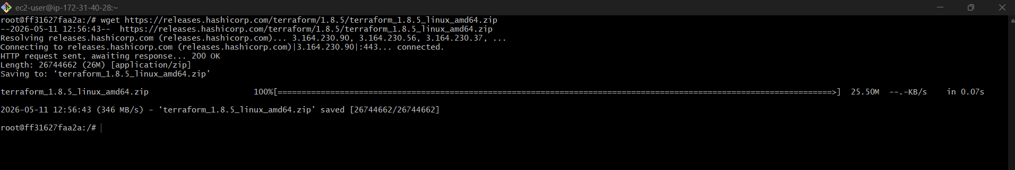

Run:
unzip terraform_1.8.5_linux_amd64.zip
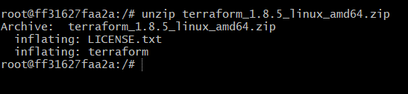
Then:
mv terraform /usr/local/bin/
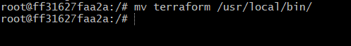

Verify
terraform version
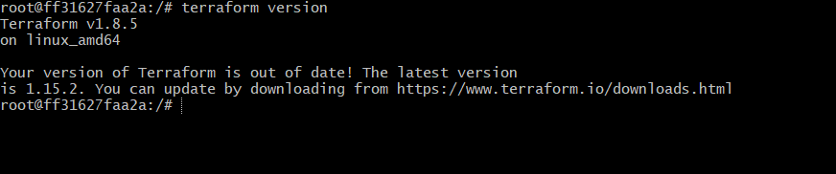

STEP 6 — Configure Jenkins Job
Go to Jenkins UI:
http://<EC2-IP>:8080
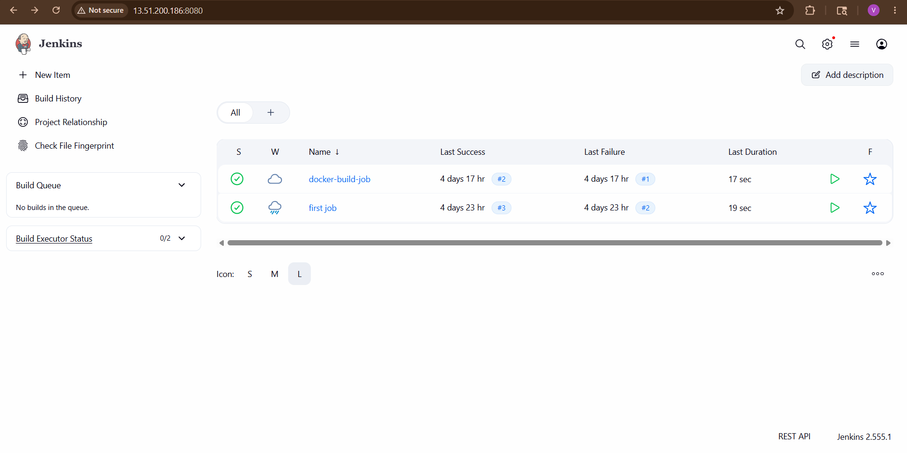
Open job:
terraform-demo
Click:
Configure
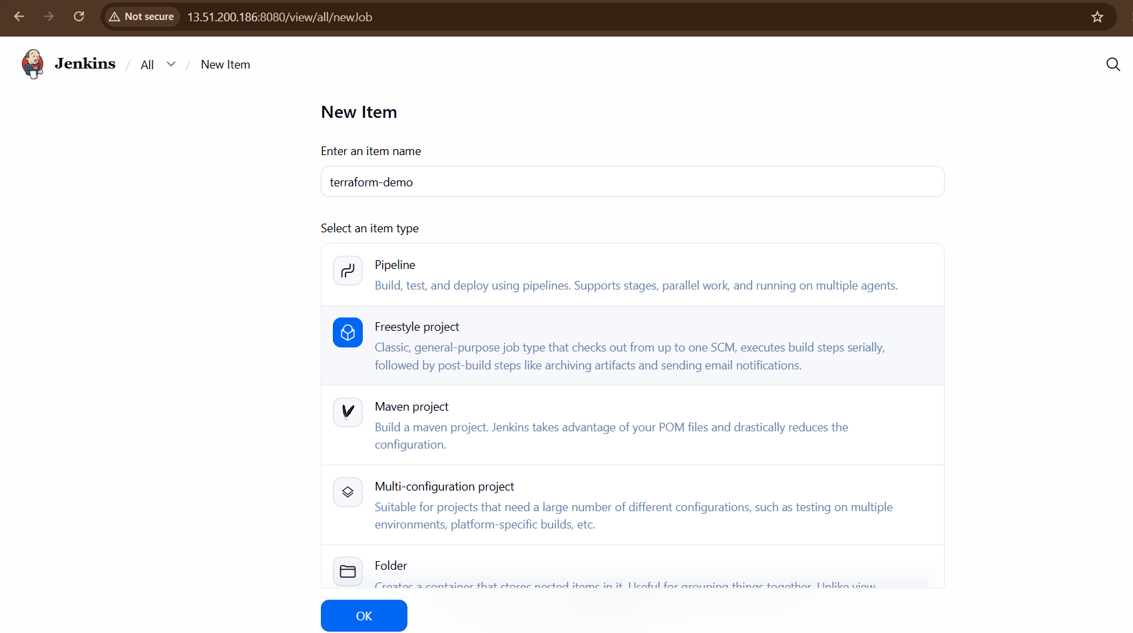

STEP 7 — Replace Build Command
Inside:
Execute Shell

Paste:
cd /var/jenkins_home/terraform-demo
terraform init
terraform plan
terraform apply -auto-approve

STEP 8 — Save Job
Click:
Save
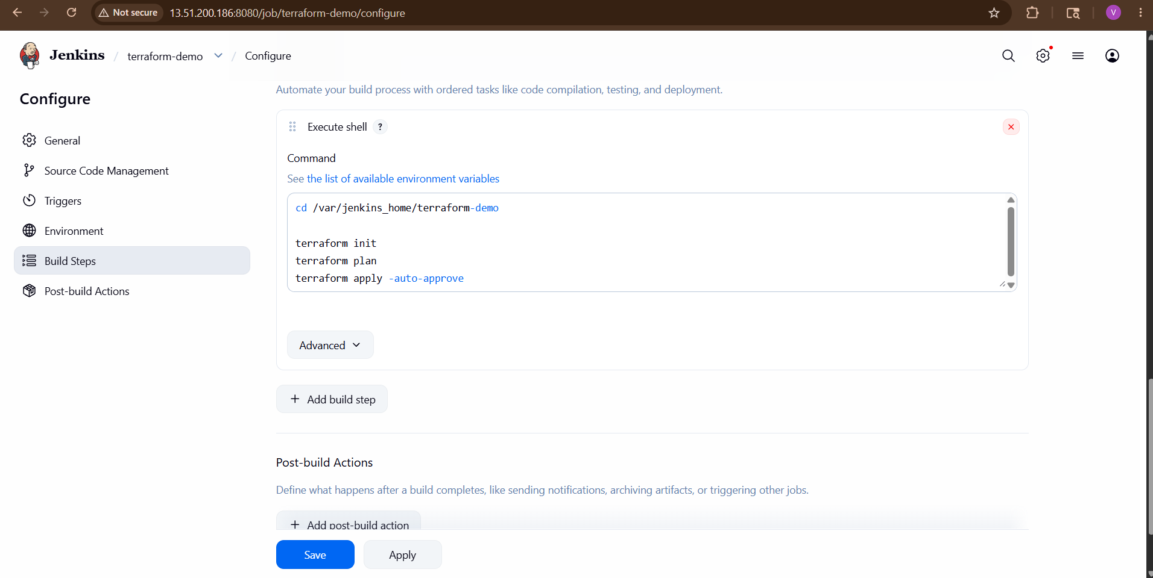

STEP 9 — Build Now
Click:
Build Now
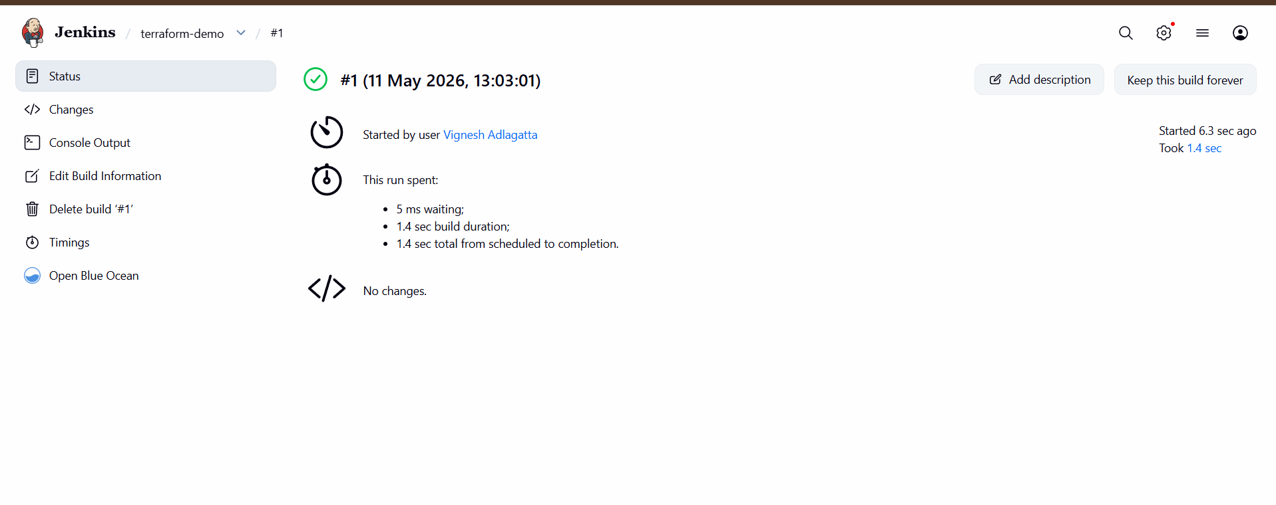

STEP 10 — Check Console Output
You should see:
Terraform has been successfully initialized!
and:
Apply complete!
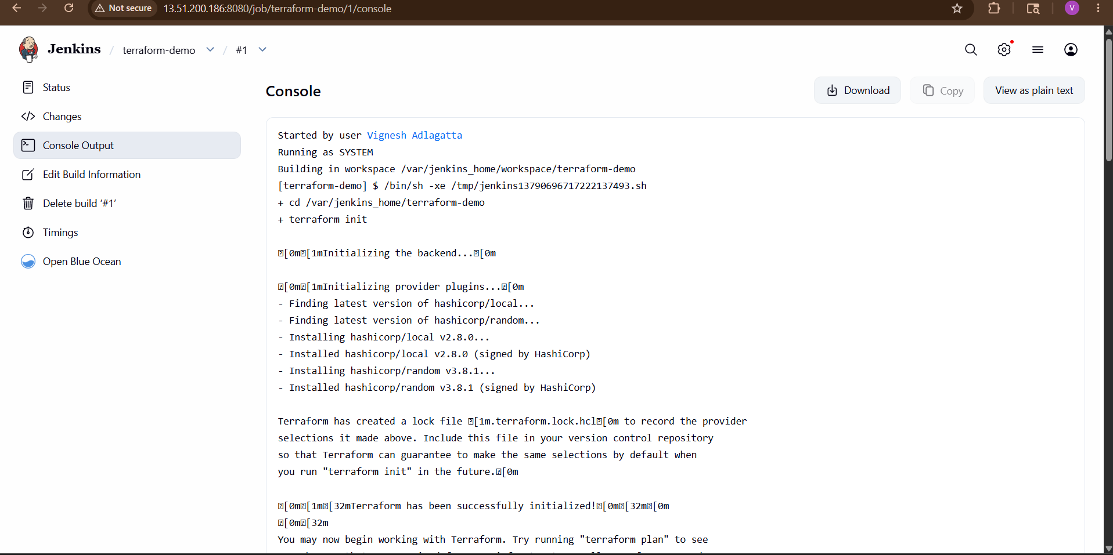
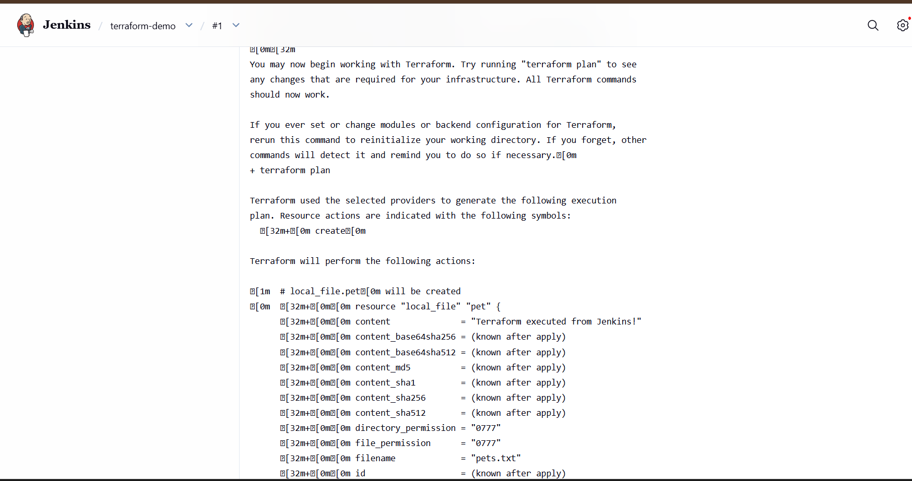
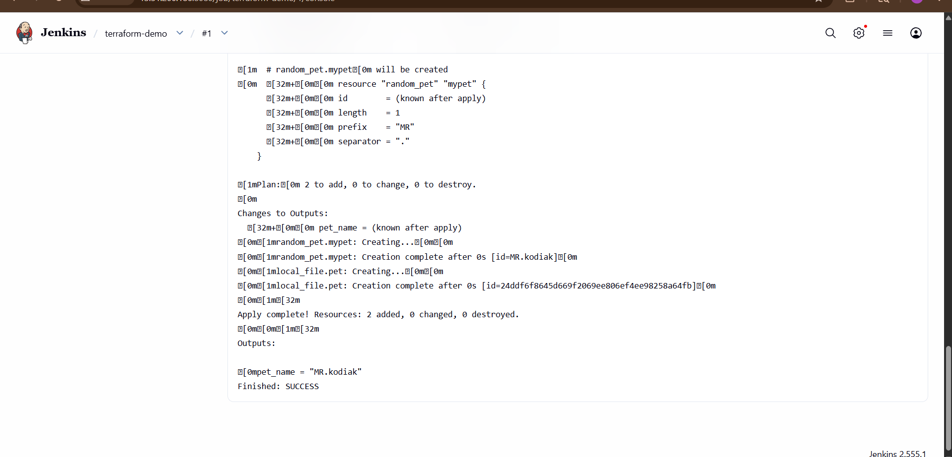
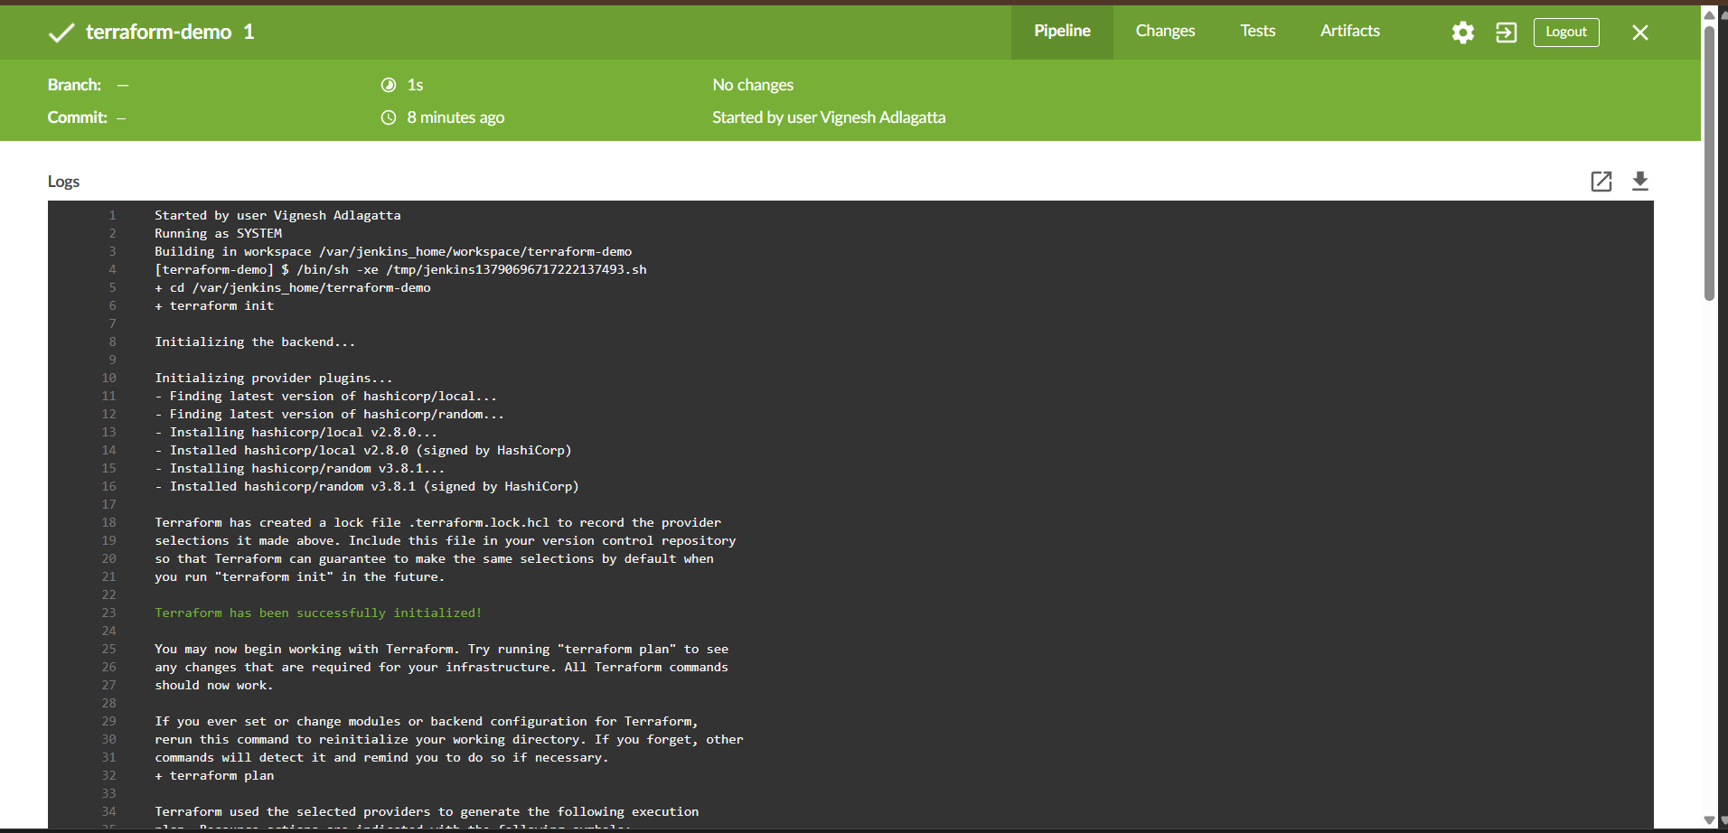
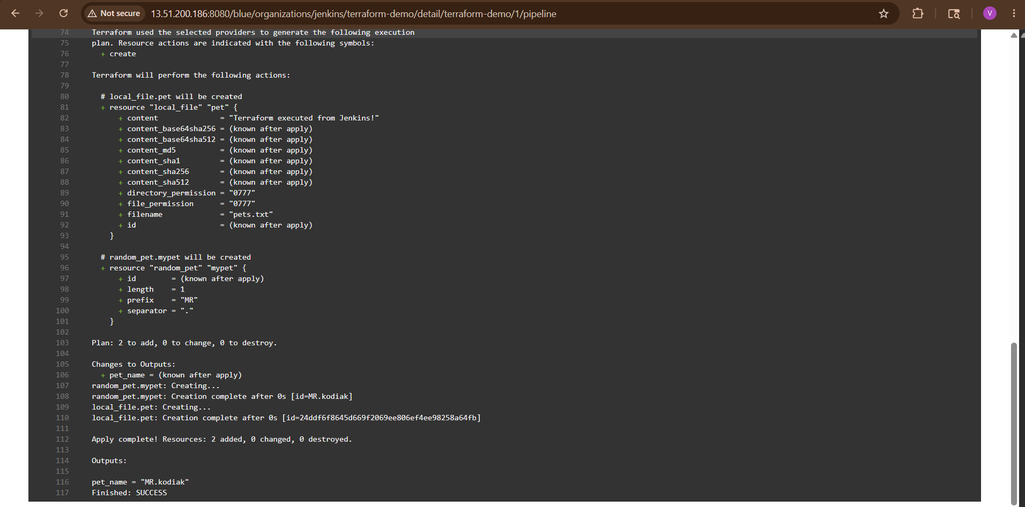

STEP 11 — Verify Generated Files
Inside container:
docker exec -u 0 -it jenkins bash
cd /var/jenkins_home/terraform-demo
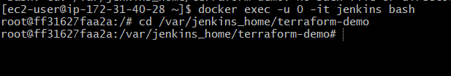
ls
You should see:
main.tf
pets.txt
terraform.tfstate

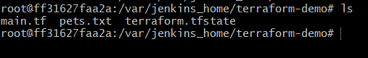

IMPORTANT CONCEPT
Component |  | Role
Jenkins |  | Automation tool
Terraform |  | Infrastructure provisioning tool
Docker Container |  | Environment running Jenkins
main.tf |  | Terraform configuration

